**INFORMATION**

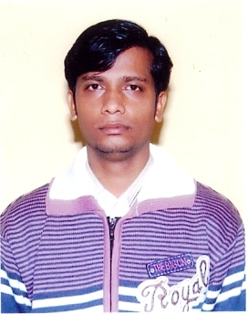

**NAME: Anil kumar Sharma**

**PASSPORT SIZE PIC:**

**Highest Qualification: M.sc IT**

**Designation: Lab Technician**

**LAB No. Assigned: CP-22 (C Block)**

**Email Id: anilsharma.cs@jecrc.ac.in**

**Experience: 8 Years**